We are excited your group has elected to travel with Bob Rogers Travel!
Below, you will find some basic trip information, and instructions on how to register with Bob Rogers Travel.
All travelers must visit the link below and complete a traveler registration to travel.

Group Name | Longmont High School | Destination | New York, NY
Group Leader | Stacy Miller | Trip Dates | April 3-7, 2020

Registration Link (case sensitive) | http://bit.ly/2020LongmontHighSchool

REGISTRATION INSTRUCTIONS

STEP 1
- Visit the link above to begin the registration process.
- You’ll be greeted with the following screen where you will need to provide your name, email, and click “Begin Signing” to get started.
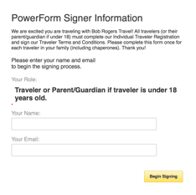

STEP 2: Agree to the use of electronic records and signatures.

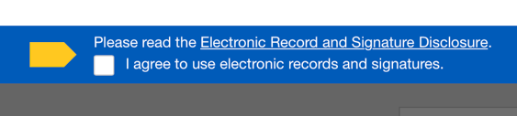
STEP 3: Complete all fields on page 1.

STEP 4: Click to sign the bottom of page 2.

STEP 5: Click finish. IMPORTANT: Your registration is not complete until you click finish. You will also be emailed a copy of the completed registration.

Thank you for choosing Bob Rogers Travel!
We look forward to helping you create lasting memories!

